| MaFEA  Overview of tool  Hololens 2 |
| --- |
| MaFEA – Making Future Education AccessiblePR2 – Guiding successful adoption |

What Hololens 2 devices are in the MaFEA project?

The MaFEA project has been using:

* 3x Microsoft Hololens 2

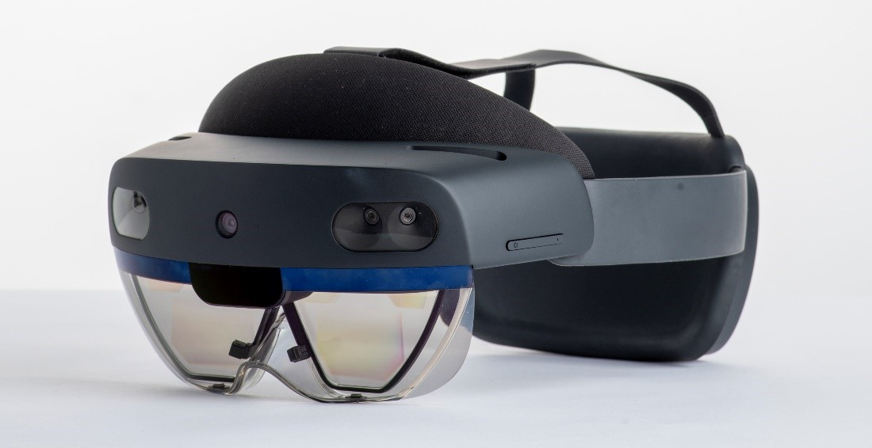

Why were these devices selected as a tool for MaFEA?

Microsoft Hololens 2 were selected as a reference to experiment MR, with the intention of developing lesson plans that promote technical skills and to equip students with the skills for a more innovative future.

Learning goals that the Microsoft Hololens 2 devices address:

Microsoft Hololens 2 devices are augmented reality technologies that offer a variety of possibilities for students' further learning. Here are some learning objectives that Hololens 2 devices can address:

1. Immersive learning: Hololens 2 devices can provide students with a more immersive learning experience by allowing them to interact with virtual objects in a simulated learning environment.
2. Exploration of virtual worlds: With Hololens 2 devices, students can explore virtual worlds that transport them to different learning contexts, from history to biology, by allowing them to view and interact with 3D objects.
3. Hands-on simulation: Hololens 2 devices can help provide hands-on training for specific professions, such as medicine, where students can simulate surgical procedures or rehearse diagnoses.
4. Remote collaboration: Through Hololens 2, students can collaborate with peers and teachers in different parts of the world, enabling collaborative learning at a distance.
5. Personalised learning: Based on student behaviour, Hololens 2 devices can deliver personalised content tailored to individual student needs, helping to improve learning effectiveness.
6. Gamified learning: Hololens 2 devices can be used to deliver gamified learning experiences, encouraging student motivation and making the learning process more fun and engaging.

In short, Microsoft Hololens 2 devices offer numerous opportunities for further student learning, enabling more immersive, personalized and collaborative learning, while offering new ways to interact with educational content.

[Tutorial links](https://mafea.eu/content/?filter_content-type=tutorial&query_type_content-type=or&filter_language=english&query_type_language=or&filter_tool=hololens-2&query_type_tool=or)

* Installing the HoloLens2
* Creating Dynamic guide for HoloLens2
* Projecting your HoloLens2 view on a external screen
* Changing account for HoloLens2
* Using HoloLens2 gestures

[Lesson plan links](https://mafea.eu/content/?filter_content-type=lesson-plan&query_type_content-type=or&filter_language=english&query_type_language=or&filter_tool=hololens-2&query_type_tool=or)