| MaFEA  Overview of tool  Pico 4 Enterprise |
| --- |
| MaFEA – Making Future Education AccessiblePR2 – Guiding successful adoption |

What is XR and why were these XR devices selected?

XR stands for “eXtended Reality” and is an umbrella term that includes Virtual Reality, Augmented Reality and Mixed Reality”.

Many devices offer more than just virtual reality experiences. As these devices begin to offer virtual and mixed reality experiences, and everything in between, the term “eXtended Reality” or “XR” has become a term to cover all.

**In the MaFEA project, it was decided that 2 Pico 4 Enterprise devices would be managed as a set.**

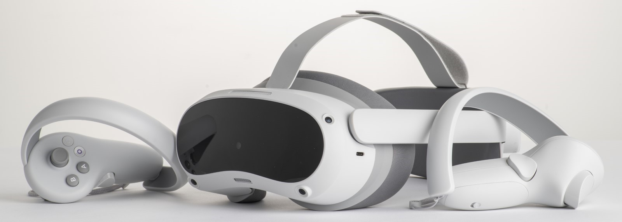

The Pico 4 Enterprise devices were selected due to these reasons:

* Interest from the teachers in the partner schools.
* Positive price / value ratio.
* Increased comfort when wearing the headset for longer periods of time.
* Comparing the Pico 4 Enterprise version to the Pico Neo 3.

Advantages to reaching learning goals that the Pico 4 Enterprise devices address:

* Offering learning processes with clear step-by-step guidance.
* Potential to make the invisible visible, and the impossible possible.
* Potential to be temporary replacements of expensive tools (e.g. repairing an engine by clicking “reset” that would otherwise cost thousands to repair.
* Potential to offer kinetic learning and retention.
* Potential to be safer than real life experiences.
* Sustainable travel to new locations.
* Less consumption of chemicals or resources, with little to no cleaning.
* Unlimited repetition of tasks at the students’ own pace.
* Boost excitement and engagement in the classroom.

[Tutorial links](https://mafea.eu/content/?filter_content-type=tutorial&query_type_content-type=and&filter_tool=pico-4-enterprise&query_type_tool=and)

[Lesson plan links](https://mafea.eu/content/?filter_content-type=lesson-plan&query_type_content-type=and&filter_tool=pico-4-enterprise&query_type_tool=and)