Changing account for HoloLens2 – v1

MaFEA – Making Future Education Accessible

PR2 – Guiding successful adoption

Changing account for HoloLens2 – v1
This guide will show you to how to
- change account
- project your HoloLens view with an external screen with a MS display adaptor
- project your HoloLens view via internet link

How to change account from your HoloLens
- Switch your account via the settings

- Tap on account

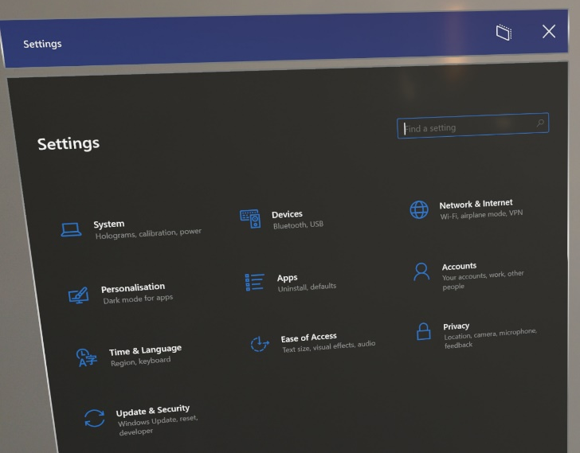

- You see the info about the account
- You can fill in the data, accountname, e-mail, …

