Taking 2D and 360 photos for use in ThingLink - v1

MaFEA – Making Future Education Accessible

PR2 – Guiding successful adoption

by Oona Haapakorpi

Taking 2D and 360 photos for use in ThingLink - v1

Introduction
This guide is designed to help you to understand how to take a good 2D or 360° Image. This document also explains how to find 360 images from ThingLink’s free image library.

How to Navigate
Additional Good to know! information has also been added to guide that you may need in the future.

Index
MaFEA – Making Future Education Accessible 0
PR2 – Guiding successful adoption 0
Taking 2D and 360 photos for use in ThingLink - v1 1
Introduction 1
How to Navigate 1
Taking 2D photos. 2
Taking 360 photos. 2
Using ThingLink’s library of 360° images 3

Taking 2D photos.
2D photos are regular photos, taken with a smart device or other camera. When taking the 2D images, always hold the device always horizontally in a landscape orientation. Horizontal orientation can also help create a sense of depth.

Taking 360 photos.
You can take your own images 360°, or you can use 360° ThingLink library images.
- Before taking your own 360° images remember to plan your photo!
  - Decide what you want to present and how you intend to do it. Remember, when setting up a 360 photo, consider the fact that the viewer will be able to explore the whole image, so try and find a location with plenty of interesting features in every direction.
  - The plan is detailed enough when you do not need to guess how to reach the desired result.
  - Create a list of the topics your 360° image will cover.
  - Choose a suitable location.
- How to take a good 360° image
  - When taking 360° images, it is essential the camera is completely still, hold the device in the correct position.
  - Adjust the camera height to eye level.
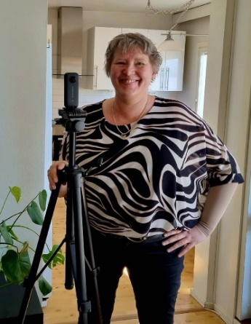
  - A must-have accessory, that should be used with every 360-degree camera is a good tripod.
  - Take the image.
Note! That the camera will capture everything surrounding it, so if you don’t want to be seen you will need to hide out of view and make use of the timer feature.
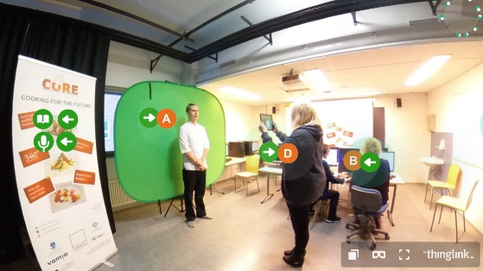

Using ThingLink’s library of 360° images
You can also make use of ThingLink’s 360° image library to create your material. The free library has more than 50 images, including Antarctica, California State Parks, Desert Habitats, and Medieval Europe.
- From the ThingLink homepage, click My content.
- Click on the left-hand side folder called “360° Library”.
- Once you have found the picture you want to use, Click on the image.
- Hover your cursor over the picture, click on 3 dots and click the Clone button.
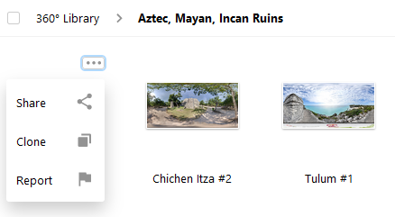
- Go back to My content. You can find the image in My content and now you can edit your clone of the 360° image

Good to know! It’s recommended that you move your image to your own folder.

