Getting the right software for Lego Spike Prime

MaFEA – Making Future Education Accessible

PR2 – Guiding successful adoption

Getting the right software for Lego Spike Prime
Getting the right software(app) to use with your Lego Spike Prime set is important. The software easily found on the website of Lego. We have provided a quick link or QR scan to the download location. (See & follow steps below)

- Scan de QR code to the right or visit this link.
- Select the correct option for your device.
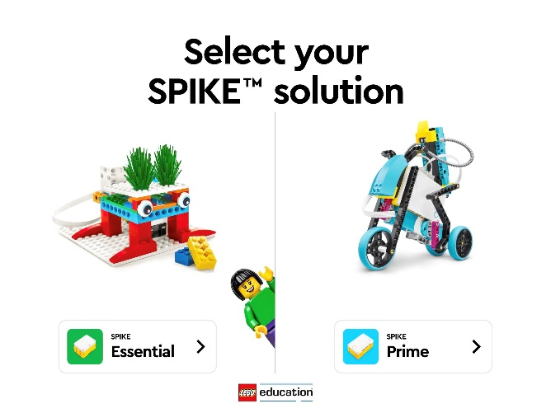
  - Optionally select the web app instead of downloading the app.
  - Download and install the app.
- Once installed, please launch the app.
- When the app starts for the first time, you will be met with the following screen: (fig 1)
- Please select Spike Prime.
- You are now on the Lego Spike home screen. (fig 2)
- The installation process is done. You can now explore the different options within the app.
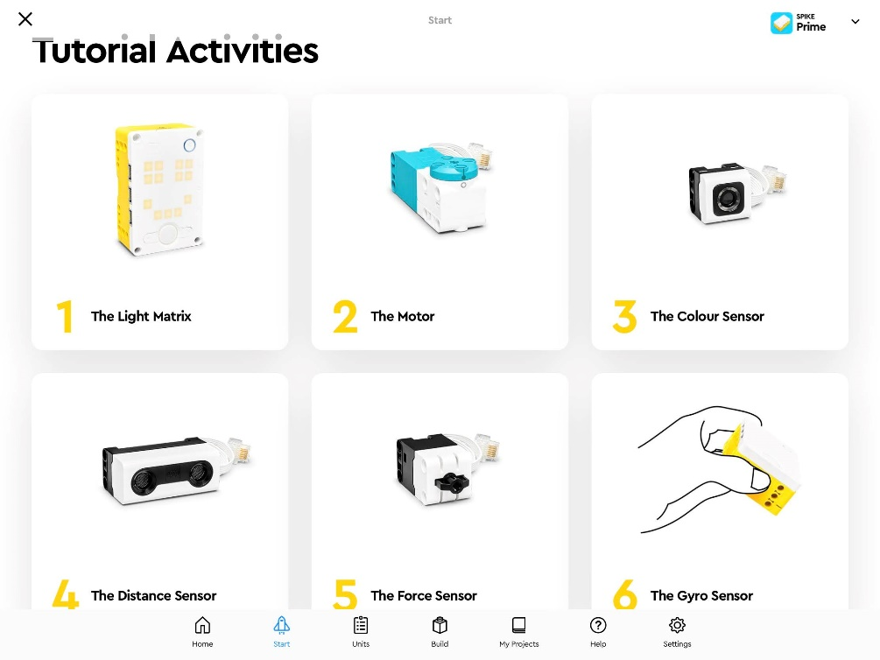
- I suggest using the ‘Get Started using Spike Prime’ option by pressing START. You will be greeted with the screen seen on fig. 3. These 6 short tutorials will further guide you towards Lego Spike Prime mastery!
Figure 1: First screen of the Lego Spike app
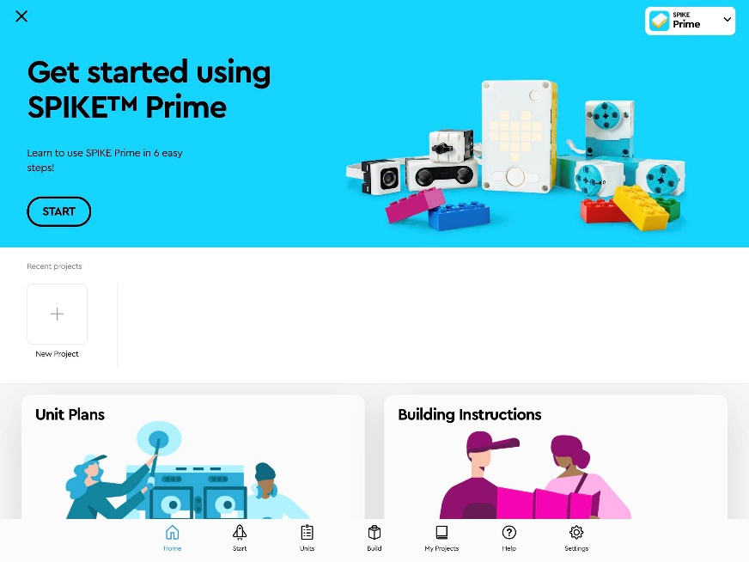
Figure 3: Tutorial screen
Figure 2: Lego Spike home screen

