|  |
| --- |
| Creating folders in ThingLink – v1 |
| MaFEA – Making Future Education AccessiblePR2 – Guiding successful adoption by Oona Haapakorpi |

Creating folders in ThingLink

## Introduction

This guide is designed to help you to understand how to create a folder.

## How to Navigate

Additional **Good to know!** information has also been added to guide that you may need in the future.

Index

MaFEA – Making Future Education Accessible 0

PR2 – Guiding successful adoption 0

Creating folders in ThingLink 1

Introduction 1

How to Navigate 1

How to create a folder 2

## How to create a folder

1. Navigate to where you want to create the folder. It is possible to create folders inside other folders.
2. Click on the + -button to create the folder.



1. Name your folder and click the Create -button.
2. You can find your folders by clicking the Content-button (1). Below is an example of three folders created in the default My content -folder (2).

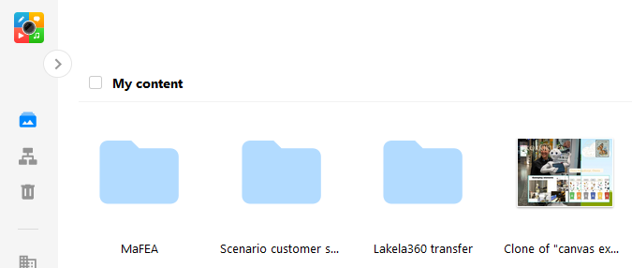

1

2