|  |
| --- |
| Creating and logging into a ThingLink account – v1 |
| MaFEA – Making Future Education AccessiblePR2 – Guiding successful adoption by Oona Haapakorpi |

Creating and logging into a ThingLink account – v1

## Introduction

This guide will help teachers or students to log into a ThingLink account. You will need:

1. An invite code.
2. An existing free ThingLink account, or to create a new free ThingLink account.

ThingLink accounts can have different licences. The most common are Free, Premium and Enterprise. Your free-licence ThingLink account can be added to an organisation (school) and use all the extra features that are included with that organisation’s licence.

In the same way, your ThingLink account can also be removed from an organisation (school), and it will become a free-licence account again.

ThingLink accounts also have different roles. The most common are Administrator, Teacher and Student.

When you create your ThingLink account, you will be asked if you are a teacher or student. It is important that you select the correct role!

Sisällys

MaFEA – Making Future Education Accessible 0

PR2 – Guiding successful adoption 0

Creating and logging into a ThingLink account – v1 1

Introduction 1

Creating a free ThingLink student account and joining a ThingLink organisation 2

Creating a free ThingLink teacher account and joining a ThingLink organisation 4

Accepting a ThingLink organisation invitation to an existing ThingLink account 7

Logging into a ThingLink account 7

Creating a free ThingLink student account and joining a ThingLink organisation

1. Navigate to [ThingLink’s eLearning pricing page](https://www.thinglink.com/signup?elearning=true).
2. Click on the Create Free Account -button.
3. Create your account:
   1. using an email address and password, or
   2. connecting an existing account of the following types: Office 365, Google, Clever, Facebook, Twitter.
   3. **Do not use the invite code at this stage!**
   4. **Good to know!** Remember which option you chose to sign up with and only use this option to log in to ThingLink from now on. If you try to log in using a different method, you will end up with multiple accounts.
   5. 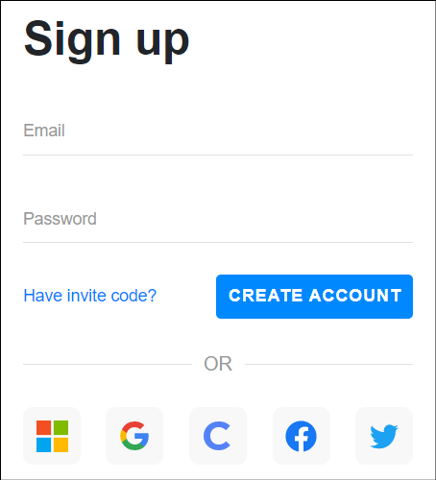
4. Click the Student -button.

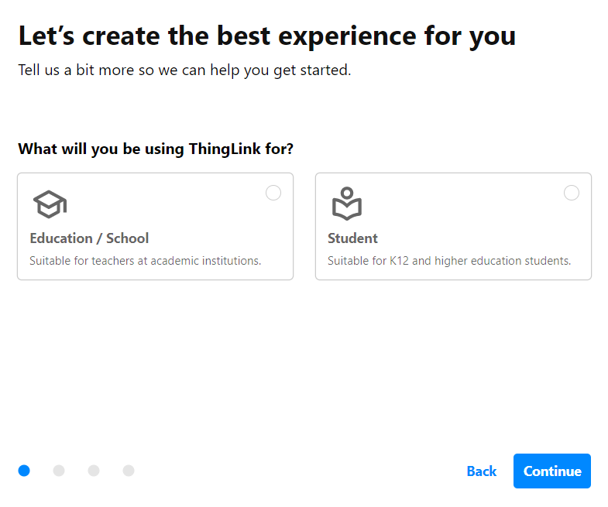

1. Provide your name, birthday and the invite code.

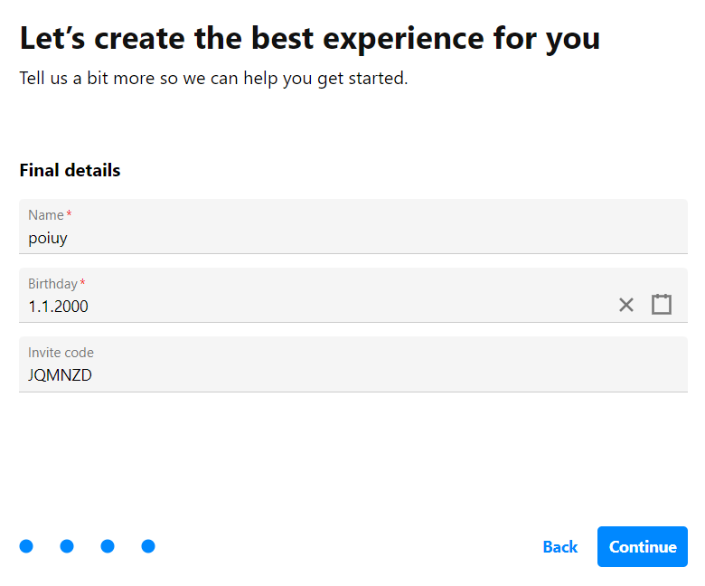

1. Your student account is created, and your account is joined to the inviting organisation.
2. Click your profile icon to confirm this.

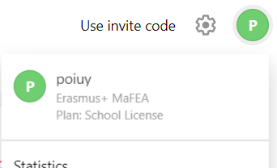

Creating a free ThingLink teacher account and joining a ThingLink organisation

1. Navigate to [ThingLink’s eLearning pricing page](https://www.thinglink.com/signup?elearning=true).
2. Click on the Create Free Account -button.
3. Create your account:
   1. using an email address and password, or
   2. connecting an existing account of the following types: Office 365, Google, Clever, Facebook, Twitter.
   3. **Good to know! Do not use the invite code at this stage!**
   4. **Good to know!** Remember which option you chose to sign up with and only use this option to log in to ThingLink from now on. If you try to log in using a different method, you will end up with multiple accounts.
   5. 
4. Click the Education / School -button.



1. Provide your role, and what purpose you will use ThingLink.
2. Provide your name, school name, teaching subject and the invite code.

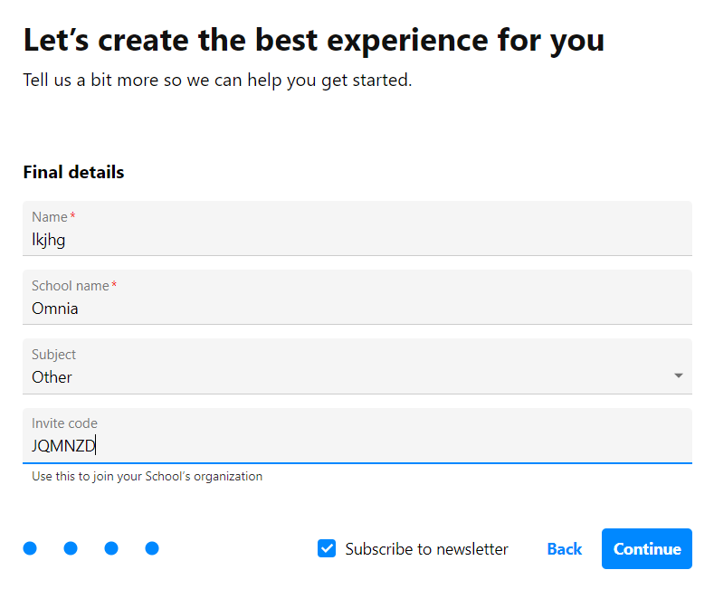

1. **Good to know!** Close the advertisement for [ThingLink Educator modules](https://www.thinglink.com/o/creator) for now. You can always access them later.
2. When asked what type of interactive content do you want to create, Click the “X” -button to close that window for now.

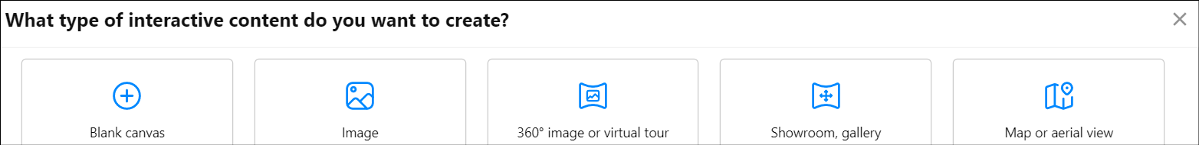

1. You should now be on your ThingLink dashboard. Your account has now been created.

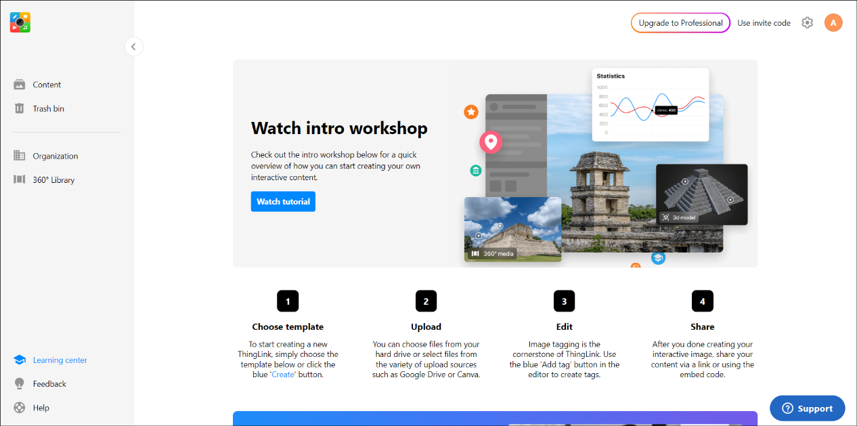

1. Your teacher account is created, and your account is joined to the inviting organisation.
2. Click your profile icon to confirm this.

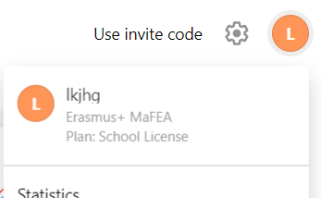

Accepting a ThingLink organisation invitation to an existing ThingLink account

1. If you have not already, log in to your free-license ThingLink account.
2. Click on the Use invite code -button.

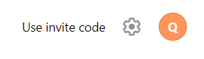

1. Type your invite code and click the Join -button.

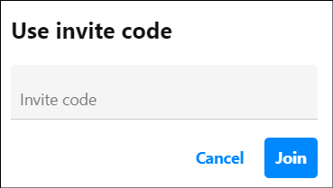

1. A notification will appear that you have joined the organisation. In this example “Erasmus+ MaFEA”.

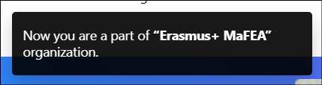

## Logging into a ThingLink account

1. Navigate to [ThingLink’s login page](https://www.thinglink.com/login).
2. Log in using the same method you used when creating your account.

